Competitive analysis

Existing products that are similar to whay I propose:

1. Gun Mayhem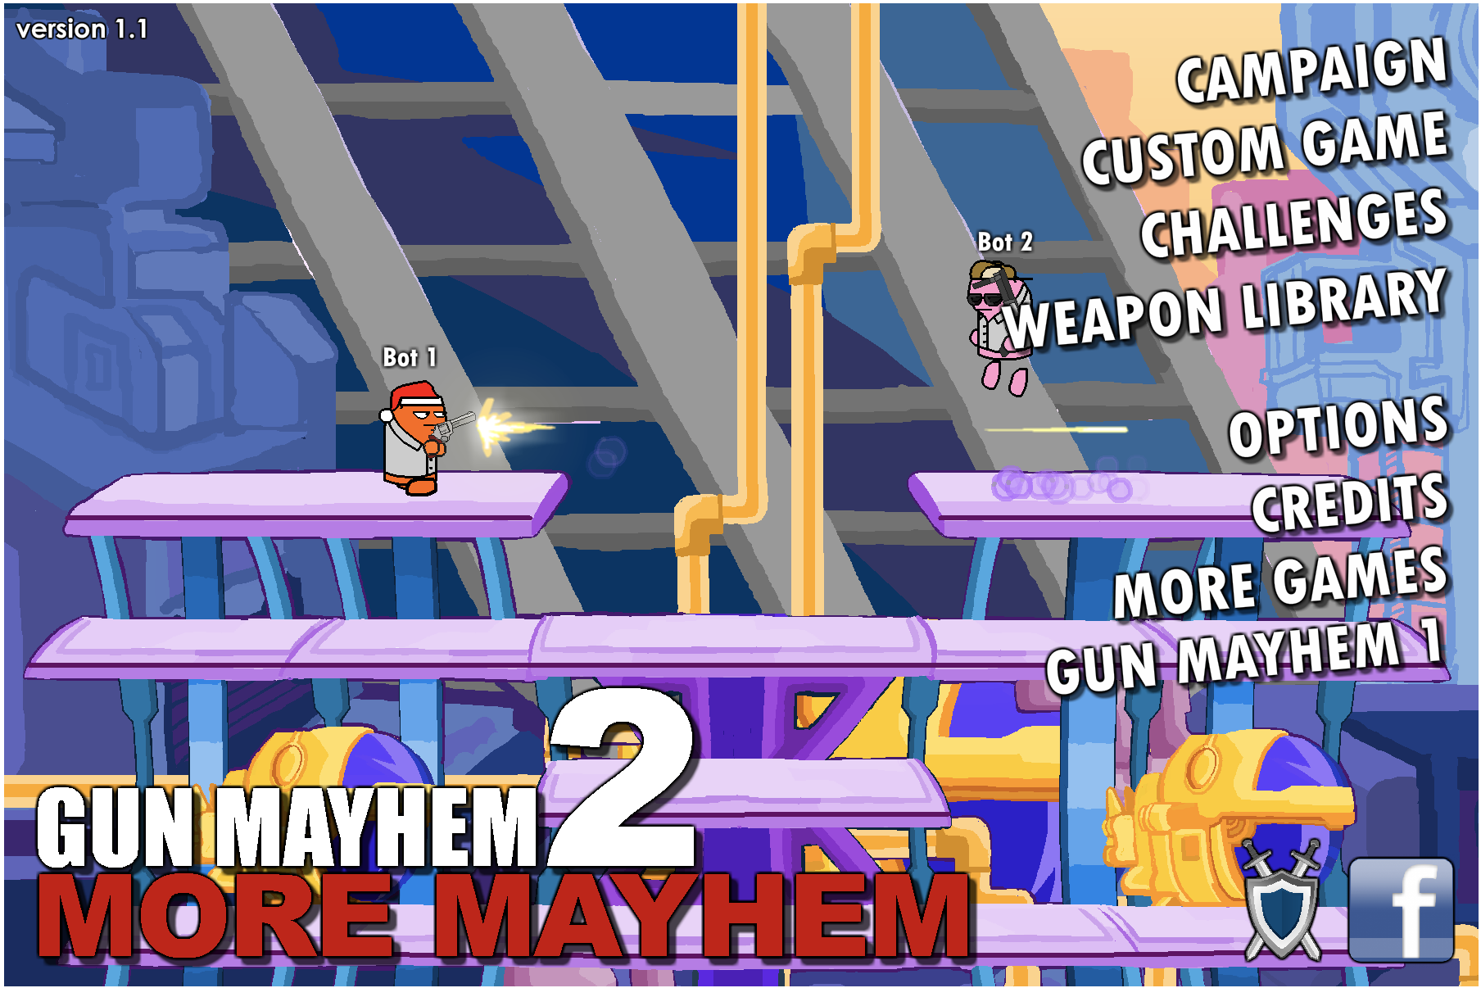

2.Little gun game

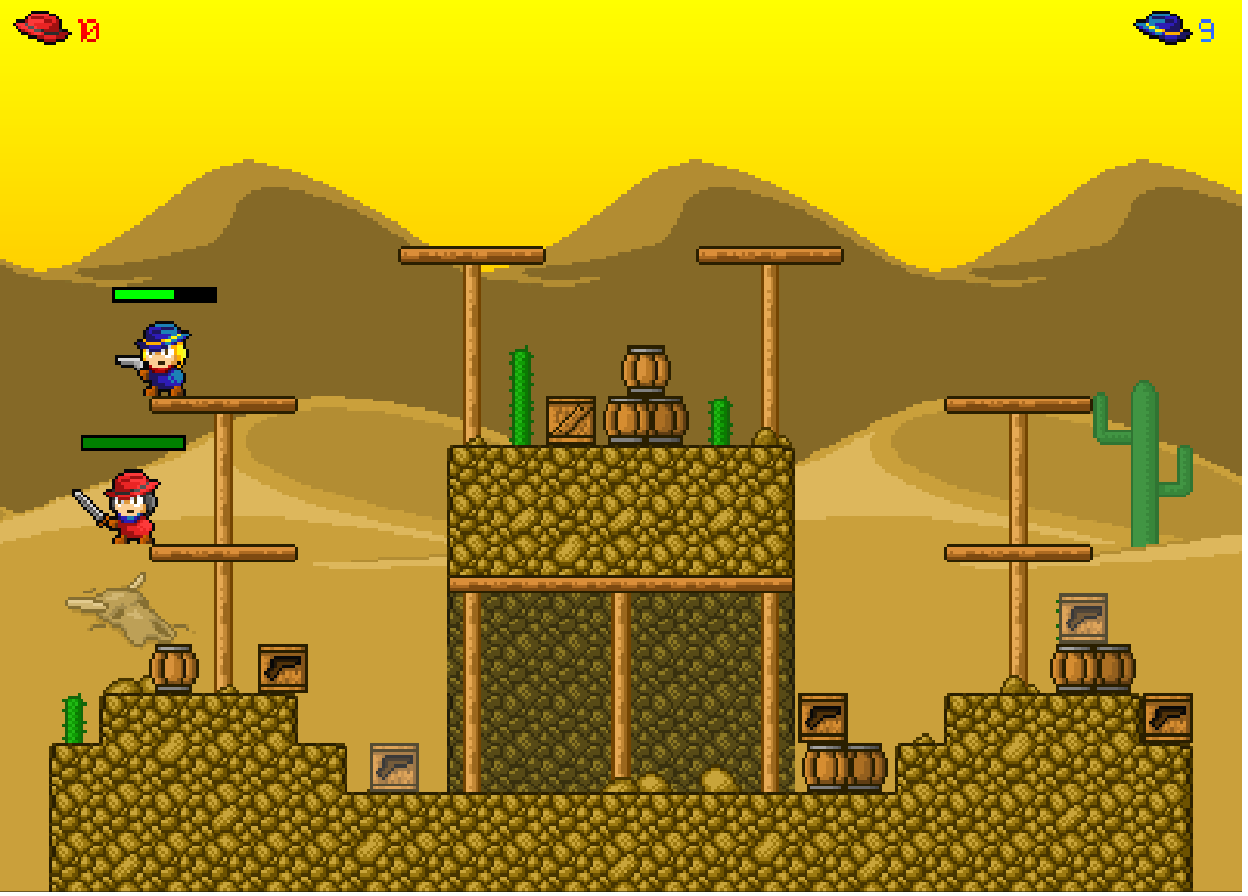

3.Chaos Faction

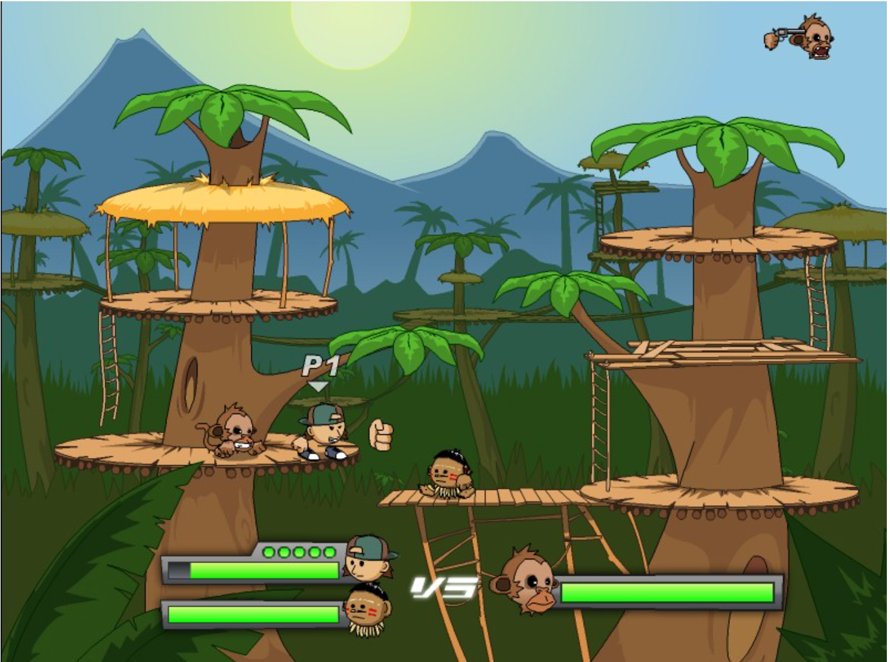

My term project inspiration came from the game named Gun Mayhem, recommended from my roommates. What I like for this game is its user experience. Besides the fantastic gun and player models as well as the special effects of gun shooting, the main feature that makes this game playable is the scroller effects. Also the Ai is very well designed and make the game more challenging and exciting. For the parts that I do not want to include in my program are some fancy special effects on scores or hits, not because it is not great but it is just not important enough. And also I do not want to include the challenges mode because I think it is a little bit boring.